$$w_{new}=w_{old}-α*{\left(\frac{dJ}{dw}\right)}_{w=w_{old}} (Graident descent)$$

$$b_{new}=b_{old}-α*{\left(\frac{dJ}{db}\right)}_{b=b_{old}} (Graident descent)$$

$$Neural Netowrk:$$

$Inputs will pass through the randomly intilased weights,$

$$it provide the output :Forward Prpogation$$

$Then will calculate error os cost \left(J\right)$

$We need to minmise the error ,$

$$will go back through the network by updating the weights :Back prpogation$$

$The technique we use to update the weights is Gradient Descent$

$$one iteration: Forward Prpogation+ :Back prpogation=Epoch$$

$$the weights will fixed , error is less$$

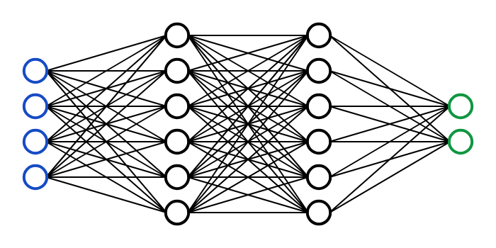

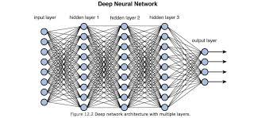

|  |  |
| --- | --- |
| Layer | Params |
| Input-8N | 0 |
| H1-9N | 8*9+9=81 |
| H2-9N | 9*9+9=90 |
| H3-9N | 9*9+9=90 |
| O-4 | 9*4+4=40 |
|  | 301 |

1024X1024 Input

10 Hidden layer 128N

Output 10N

|  |  |
| --- | --- |
| Layer | Params |
| Input- 1048576 | 0 |
| H1-128N | 8*9+9=81 |
| H2-9N | 9*9+9=90 |
| H3-9N | 9*9+9=90 |
| H4 |  |
| H5 |  |
| H6 |  |
| H7 |  |
| H8 |  |
| H9 |  |
| H10 |  |
| O-4 | 9*4+4=40 |
|  | 301 |

Saurv 1024 X1024

110 Images ============== NN

$$Gradient descent is divided into 3 ways$$

$Batch gradient descent$

$All the train observations we are passing at a time to NN$

$Asume that 50k train samples are there$

$will pass all the 50k observations at a time$

$Average error you will calculate$

$again it will come back to update the weights$

$For Forward prpogation 1 sample====== >1 min$

$For 50k observation : 50k\min{ required for only Forward prpogation}$

$For backward prpogation aslo 50K min$

$For one epoch 50k\min{ + 50k \min{=100k min}}$

$When we calculate average error: Avg( 50K)$

$Mini batch gradient descent:$

$$Divide data into batches$$

$50k divided into 50 Batches$

$Each batch 1000 observations$

$Forward +Backwards is become fast$

$$When we calculate average error: Avg( 1K)$$

$Stochastic gradient descent$

$One by one observation will go$

$$When we calculate average error: Avg( 1K)$$

$$who wil reach the minmum point first and How they reach$$

$$who wil reach the minmum point first:Convergence$$

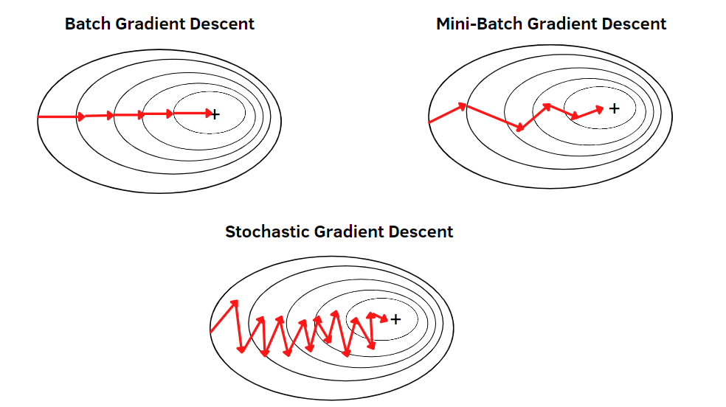

Which type of Gradient descent will use in which cases?

$$w_{new}=w_{old}-α*{\left(\frac{dJ}{dw}\right)}_{w=w_{old}}$$

$$Step-1: will randomly intialise the weight and bias$$

$$Step-2: y=bo+w*x$$

$$Step-3:when we substitute b_{o} and w and pass the input will get y_{predictions}$$

$$Step-4:we are calculating the error$$

$$Step-5: Total cost function =avg of all error^{2}$$

$$Step-6:will differentaite the cost function wrt weight$$

$$Step-7:We choose the learing rate$$

$$Step-8:we are upading the weights w_{new}=w_{old}-α*{\left(\frac{dJ}{dw}\right)}_{w=w_{old}}$$

$$Step-9:The same process happend for bias also$$

$$Step-10:The entire flow will repeated many time (epochs)$$